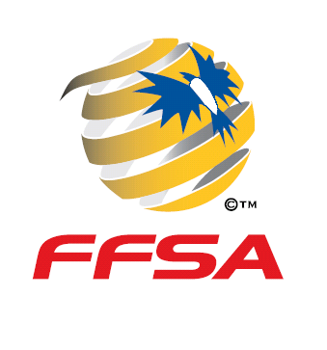
SAJSA - South Australian Junior Soccer Associations Inc

COUNTRY 2018

ASSOCIATION: _____________________________________________________ AGE GROUP: _____U/_________________

SHIRT NO. | SURNAME | CHRISTIAN | CLUB or SCHOOL | DATE OF BIRTH | REG. NO. | PARENT/GUARDIAN  SIGNATURE

PARENT / GUARDIAN DECLARATION
Each Parent / Guardian by signing above, certifies that the player named on the form has their permission to play soccer in any competition organised by SAJSA,
or any member association, that arranges and runs an event on behalf of SAJSA. The Parent / Guardian further agrees that they will not hold the SAJSA, or any member Association, liable for any hospital or medical expenses that may be incurred as a result of injuries sustained whilst participating in said event.
FORM A COACH ___________MANAGER____________REGISTRAR______________

